MONDAY EXERCICES

## Q1 HTML Formatting

|  |  |  |
| --- | --- | --- |
| **Tags** | **Display** | **Match** |
| A. <strong>Text here</strong> | 1. Text here | A …3…… |
| B. <em> Text here </em> | 2. *Text here* | B …2……. |
| C. <del> Text here </del> | 3. **Text here** | C …4……. |
| D. <u> Text here </u> | 4. ~~Text here~~ | D …1……. |

## Q2 Ordered list

<ol>

<li>Item here</li>

</ol>

|  |  |  |
| --- | --- | --- |
| **Types** | **Display** | **Match** |
| A. list-style:none; | 1/ a. Item here | A …4…… |
| B. type=”a”; | 2/ I. Item here | B …1……. |
| C. type=”A”; | 3/ 1. Item here | C …5……. |
| D. type=”I”; | 4/ Item here | D …2……. |
| E. type=”i”; | 5/ A. Item here | E …6……. |
| F. type=”1”; | 6/ i. Item here | F …3……. |

## Q3 Unordered list

<ul>

<li>Item here</li>

</ul>

|  |  |  |
| --- | --- | --- |
| **Type** | **Display** | **Match** |
| A. list-style:**none**; | 1/ Item here | A …3… |
| B. list-style:**disc**; | 2/ Item here | B ……1…. |
| C. list-style:**circle**; | 3/ Item here | C ……4…. |
| D. list-style:**square**; | 4/ Item here | D ……2…. |

## Q4 Cascading Style Sheets

|  |  |  |
| --- | --- | --- |
| **Type** | **Display** | **Match** |
| A. <link rel=”stylesheet” href=”main.css” /> | 1/ Inline style sheet | A …1…… |
| B. <style>  body { background: green; }  </style> | 2/ External style sheet | B …3……. |
| C. <h1 style=”color:blue;”>Heading 1</h1> | 3/ Internal style sheet | C …2……. |

## Q5 Hyperlinks

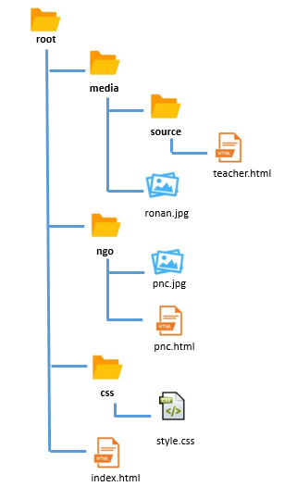

A. Write the link from **index.html** to **style.css**

…..<a href=”CSS/style.css>style</a>…….

B. Write the link from **index.html** to **teacher.html**

……<a href=”media/soure/teacher.html”>teache</a>……

C. Write the link from **pnc.html** to **teacher.html**

….<a href=”…media/source/teacher.html”>teacher</a>…

D. Write the link from **pnc.html** to **ronan.jpg**

….<a href=”…/media/ronan.jpg”>ronan</a>……

E. Write the link from **teacher.html** to **pnc.jpg**

…<a href=”…/…/ngo.pnc.html”>pnc</a>….

F. Write the link from **teacher.html** to **style.css**

…<a href=”…/…/css/style.css”>style</a>…….

## Q6

Complete the CSS code to fulfill requirements.

|  |  |
| --- | --- |
| HTML | Browser |
| <body>  <a href=”#” >pnc cambodia</a>  </body> | **PNC CAMBODIA** |

|  |
| --- |
| CSS |
| // your code here  a{  text-transform:uppercase;  text-decoration:none;  } |
|  |
| * The text shall be bold with a sans-serif font |

## Q7

Complete the CSS code to fulfill requirements.

|  |  |
| --- | --- |
| HTML | Browser |
| <body>  <div class=”tealBox”></div>  </body> |  |

|  |
| --- |
| CSS |
| // Your code here  .tealBox{  background: blue;  width:200px;  height:200px;  } |
| Specifications |
| * The teal box shall be the same width and height [200px] |

## Q8

Complete the CSS code to fulfill requirements.

|  |  |
| --- | --- |
| HTML | Browser |
| <body>  <div id=”circle”></div>  </body> |  |

|  |
| --- |
| CSS |
| // Your code here  div{  background:green;  width:200px;  height:200px;  border-radius:50%;  } |
| Specifications |
| *div circle :*   * The green circle shall be the same width and height [200px] |

## Q9

Complete the CSS code to fulfill requirements.

|  |  |
| --- | --- |
| HTML | Browser |
| <body>  <div class=”orangeBox”>Box One</div>  </body> |  |

|  |
| --- |
| CSS |
| // Your code here  .orangeBox{  height:200px;  width:200px;  background-color:orange;  font-family:sans-serif;  font-weight:bold;  color:white;  align-items: center;  justify-content: center;  display:flex;  } |
| Specifications |
| * The text in orange box shall be centered vertically and horizontally * The orange box text shall be bold with a sans-serif font |

## Q10

Complete the CSS code to fulfill requirements.

|  |  |
| --- | --- |
| HTML | Browser |
| <body>  <div class="box one">Box One</div>  <div class="box two">Box Two</div>  <div class="box three">Box Three</div>  </body> |  |

|  |
| --- |
| CSS |
| // Your code here  .box{  width:200px;  height:200px;  border:5px solid #ddddd;  float:left;  text-align:center;  vertical-algin:middle;  line-height:200px;  color:white;  }  .one{  background-color:orange;  font-weight:bold;  font-family:sans-serif;  }  .two{  background-color:teal;  }  .three{  background-color:blue;  } |
| Help |
| * The all box shall be the same width and height [200px] * The text in all box shall be centered vertically and horizontally * The orange box text shall be bold with a sans-serif font |